SPRINT-4

|  |  |
| --- | --- |
| TEAMID | PNT2022TMID08727 |
| ProjectName | IoTBasedsmartcropProtectionsystemforagriculture |
| Maximummark | 20marks |

STEP1:MITAPP inventortodesigntheAPP.

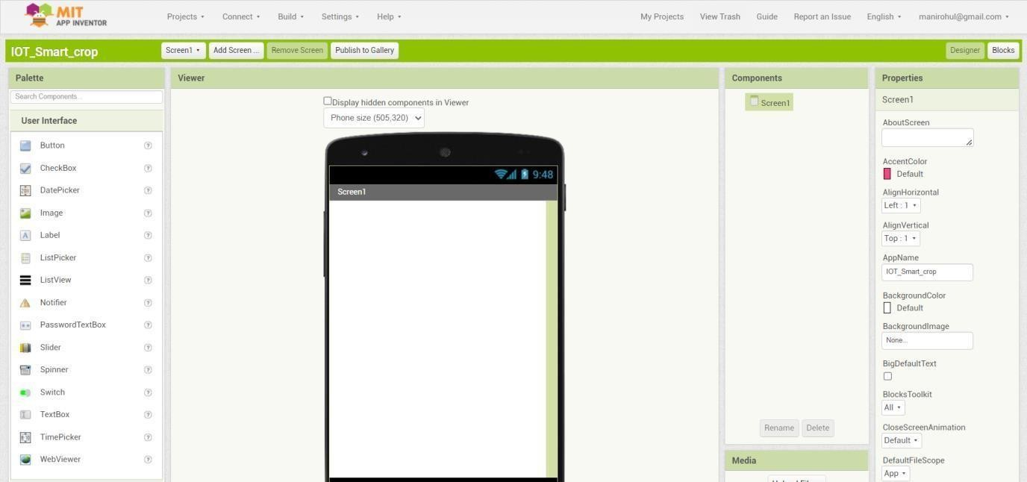

STEP2:Customize theAppinterfacetoDisplaythe Values.

